***Daily Website Performance Reports***

**Objective and Purpose:**

The objective of this project is to generate performance reports of listed websites from a user's point of view using Lighthouse and send them via email to the developers. The purpose of the project is to provide a quick and easy way for the developers to monitor the performance of multiple websites and identify any issues that may be impacting the user experience.

**Scope:**

The scope of this project includes to add all websites urls in sitemap table and then fetching URLs from a sitemap, testing each URL using Lighthouse, storing the results in a database, creating zip files of logs and attachments, and then emailing the report to specified email addresses. The project focuses on providing performance reports from a user's point of view, including factors such as website speed, accessibility, best practices, and SEO. The project does not involve any monitoring or analysis of server-side metrics such as server response time, CPU usage, or memory usage. The project also does not involve any modifications to the websites being monitored.

**Database Schema:**

**websitestat**

**sitemap:** (sitemapurls)

**suburls:** (records, id, tags, createdOn)

**logsPD:** (Id, Url_Tested, MobilePerformance, MobileAccessibility, MobileBestPractices, MobileSeo, M_FCP, M_LCP, M_CLS, M_TBT, M_TTI, M_SI, DesktopPerformance, DesktopAccessibility, DesktopBestPractices, DesktopSeo, D_FCP, D_LCP, D_CLS, D_TBT, D_TTI, D_SI, CreatedOn)

**Database Details:**

The project uses database, "websitestat”.

"websitestat" database has one table "sitemap" which stores the sitemap URLs of each website that needs to be monitored. The schema of the "sitemap" table has 1 columns - "sitemapurls". The "sitemap_url" column stores the URL of the sitemap.

The "suburl" table of "websitestat" database has 4 columns - "records", "id", "tags", "createdOn".

"id" column is a primary key,

"record" column stores the individual page or post URL extracted from the sitemap

”tags” columns write the tag if the url is autofetched or not

"createdOn" column store the date and time when the record was created

The "logsPD" table, which stores the performance reports generated by Lighthouse for each URL tested. The schema of the "logsPD" table has 23 columns - Id, Url_Tested, MobilePerformance, MobileAccessibility, MobileBestPractices, MobileSeo, M_FCP, M_LCP, M_CLS, M_TBT, M_TTI, M_SI, DesktopPerformance, DesktopAccessibility, DesktopBestPractices, DesktopSeo, D_FCP, D_LCP, D_CLS, D_TBT, D_TTI, D_SI, CreatedOn. The "id" column is a primary key, "Url_Tested" column stores the URL of the tested page or post, and "performance", "accessibility", "best_practices", and "seo" columns store the scores generated by Lighthouse for each factor. "createdOn" column stores the date and time when the record was created.

**Repository structure**

- PerformanceReports/

-DailyPerformanceReports/

- FetchUrls/

- Sitemapurls.php

- Main/

- urlfilecreation.php

- main.js

- index.php

- zip.php

- delete.php

- MailPhp/

- sendmail4.php

The main project directory is " PerformanceReports/DailyPerformanceReports", which contains three subdirectories –

"FetchUrls",

"Main",

"MailPhp"

that provides an overview of the project.

The "FetchUrls" directory contains "Sitemapurls.php" file, which is responsible for reading the sitemap URLs from the "sitemap" table in "websitestat" database and fetching the page and post URLs from those sitemaps and store the fetched URLs to the table “suburls” in "websitestat".

The "Main" directory contains five files - "urlfilecreation.php", "main.js", "index.php", "zip.php", and "delete.php" - that are responsible for generating the “urls.csv” file which fetch the urls from the database table “suburls” and generating performance reports, creating zip files of the logs and saving the logs in the database table logsPD.

The "MailPhp" directory contains "sendmail4.php" file, which is responsible for sending the emails containing the performance reports fetched from the database table logsPD.

**Scheduled tasks in Task Scheduler:**

**FetchUrls:** This task should be run to fetch all the URLs from the sitemap and store them in the "suburl" table in the "websitestat" database. The command to run this task is:

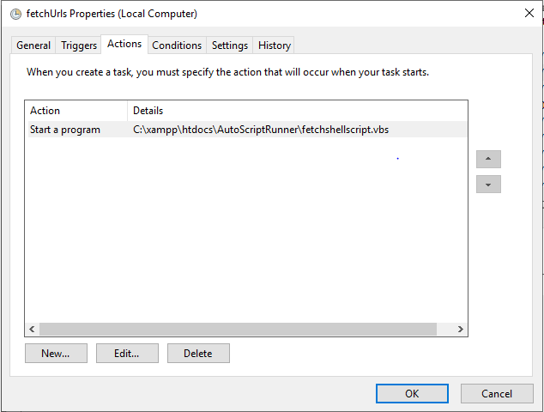

**FileCreation:** This task should be run to create a CSV file containing all the URLs in the "suburl" table. The command to run this task could be something like:

**NodeDailyPerformance:** This task should be run to test the performance of each URL using Lighthouse and store the results in the "logsPD" table in the "websitestats3" database. The command to run this task could be something like:

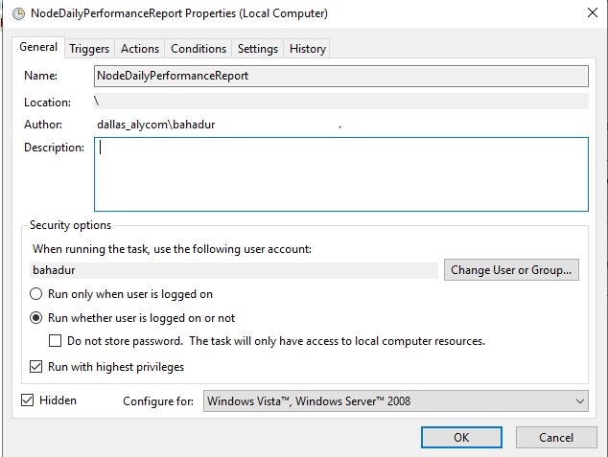

These tasks should be scheduled to run at appropriate intervals using a tool cron.